|  |
| --- |
| **MATHEMATICS DEPARTMENT 2015**  **Year 11 Specialist - Test Number 6**  **Resource Free**  Transformations and Trigonometric Functions |



**Name: _______________________________ Teacher: DDA**

**Marks: 28**

**Time Allowed: 25 minutes**

**Instructions:** You arepermitted no notes or calculators.

_________________________________________________________________________

8multiple-choice questions

1 mark each: 8 marks

Circle the correct answer.

1 What is the matrix for the translation of A(2, 5) B(–3, 3)  Aʹ(4, 3) Bʹ(–1, 1)?

A 

B 

C 

D 

E 

[1 mark]

2 What is the transformation for the matrix?

A (x, y)  (2y – 3x, 2x – y)

B (x, y)  (3x – 2y, 2x – y)

C (x, y)  (2y – 2x, 3x – y)

D (x, y)  (3y – 2x, 2x – y)

E (x, y)  (2x – 2y, 3x – y)

[1 mark]

3 What is the image of the triangle A(6, 4) B(2, 6) C(8, 12) under the dilation with factor 0.5 in the x-direction and 2 in the y-direction?

A Aʹ(12, 8) Bʹ(4, 12) Cʹ(16, 24)

B Aʹ(12, 2) Bʹ(4, 3) Cʹ(16, 6)

C Aʹ(3, 8) Bʹ(1, 12) Cʹ(4, 24)

D Aʹ(3, 2) Bʹ(1, 3) Cʹ(4, 6)

E Aʹ(3, –8) Bʹ(1, –12) Cʹ(4, –24)

[1 mark]

4 What is the matrix for a rotation of ?

A 

B 

C 

D 

E 

[1 mark]

5 The amplitude of the graph y = –3 sin  is:

A 2

B –2

C 3

D –3

E 4

[1 mark]

6 The period of the graph y = 5 sin is:

A π

B 

C 2π

D 

E 

[1 mark]

7 The amplitude, period and phase shift of the graph y = 2 sin  are respectively:

A 2, π,  horizontally to the left

B –2, π,  horizontally to the right

C π, 2,  horizontally to the left

D 2, 2π,  horizontally to the left

E 2, 2π,  horizontally to the right

[1 mark]

8 The period and phase shift of the graph y = 2 cos (4x – π) are respectively:

A 4π, π horizontally to the left

B ,  horizontally to the right

C ,  horizontally to the left

D , π horizontally to the right

E , π horizontally to the left

[1 mark]

4 short answer questions

20 marks

Show your working where appropriate.

9 T1 is a reflection in the line through the origin with inclination .

T2 is a reflection in the line through the origin with inclination .

a Find

|  |
| --- |
|  |
|  |

b Find

|  |
| --- |
|  |
|  |

c Express the transformation T1  T2 as a matrix.

|  |
| --- |
|  |
|  |
|  |
|  |
|  |
|  |
|  |
|  |
|  |
|  |
|  |

d What kind of transformation is T1  T2?

|  |
| --- |
|  |
|  |

[2,2,2,2: 8 marks]

10 The transformation T is represented by the matrix

1. Describe in words the transformation T.

|  |
| --- |
|  |
|  |

1. The transformation T is applied to the line with equation . Find the equation of the resulting line.

|  |
| --- |
|  |
|  |

1. The point A is mapped to the point with coordinates (k, k + 1) under transformation T. Find the coordinates of the point A.

|  |
| --- |
|  |
|  |

1. What is the transformation matrix for dilation of factor 3 in the x-direction?

|  |
| --- |
|  |
|  |

[4 marks]

11 For the function below, answer the following questions for 0 ≤ x ≤ 2 π.

|  |  |  |  |  |
| --- | --- | --- | --- | --- |
|  | What is the maximum value? | For what value(s) of x does the maximum occur? | What is the minimum value? | For what value(s) of x does the minimum occur? |
| y = –1 – 4 cos (x – π) |  |  |  |  |

[4 marks]

12 Solve for all values of.

|  |
| --- |
|  |
|  |
|  |
|  |
|  |
|  |
|  |
|  |
|  |
|  |
|  |

[4 marks]

|  |
| --- |
| **MATHEMATICS DEPARTMENT 2015**  **Year 11 Specialist - Test Number 6**  **Resource Rich**  Transformations and Trigonometric Functions |



**Name: _______________________________ Teacher: DDA**

**Marks: 20**

**Time Allowed: 20 minutes**

**Instructions:** You arepermitted 1 A4 page of notes and your calculators. Show your working where appropriate.

_________________________________________________________________________

13 Using a calculator, solve the equation  = 1 for 0 ≤ x ≤ π.

|  |
| --- |
|  |
|  |

[1 mark]

14 Given transformation matrix T =

a Find the image of the trapezium A(3, –2) B(5, 3) C(1, 6) D(–3, –4) under the transformation T.

|  |
| --- |
| A’= |
| B’= |
| C’= |
| D’= |
|  |
|  |

c What shape is the image?

|  |
| --- |
|  |
|  |

[4,1: 5 marks]

15 The area of the triangle ABC is 27.5 cm2. Find the area of the image of the triangle ABC after the transformation T: (x, y) (4x – y, 2x + 5y).

|  |
| --- |
|  |
|  |
|  |
|  |
|  |
|  |
|  |
|  |
|  |

[3 marks]

16 The displacement of a particle is given by x = 3 sin (2t) + cos (2t).

a Express the displacement in the form x = r sin (2t + ) giving r in exact form and to 2 decimal places and in radians.

|  |
| --- |
|  |
|  |
|  |
|  |
|  |
|  |
|  |
|  |
|  |
|  |

[5 marks]

b Hence find the greatest distance that this motion reaches from the mean point.

|  |
| --- |
|  |

[1 mark]

17 The time between successive high tides at a pier is 12 h 34 min. The average depth of water is 4 m, but at low tide it is 3.1 m. The tide can be modelled by

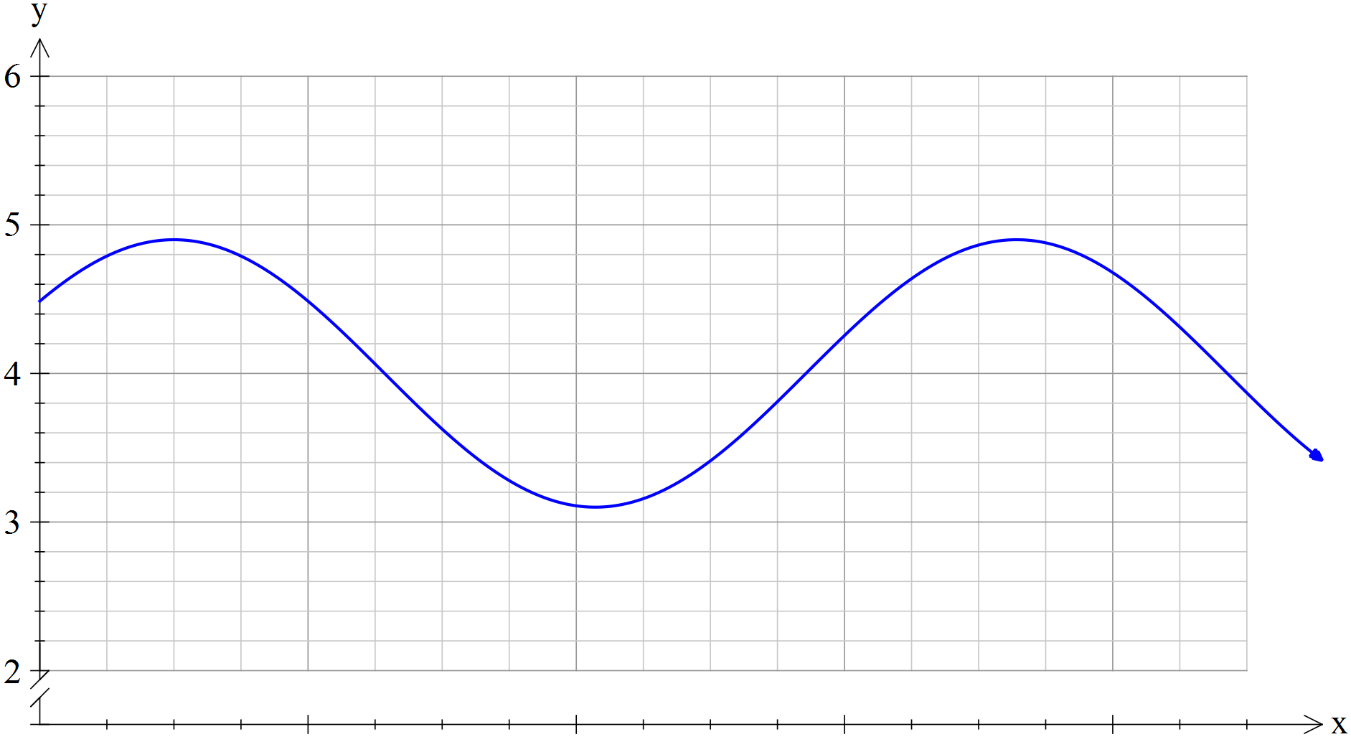

1. Determine the values of and in the equation.

|  |
| --- |
|  |
|  |

1. Find the length of time that a boat can use the pier if it is only able to dock when the tide is between 3.5 and 4.5 metres.

|  |
| --- |
|  |
|  |
|  |
|  |
|  |
|  |
|  |
|  |
|  |
|  |

[5 marks]